Individual report

Corporate Social Responsibility:
Overconsumption and its impact on climate change

Focus case: ZARA’s ‘Fast fashion’
Word count: 2197

Executive summary
This report describes the interconnection between overconsumption of consumer goods and climate change, focusing on textile products and ‘fast fashion’ garments. ZARA company was chosen as a case being examined in the report. ZARA is one of the most successful and influential companies in the textile industry currently operating 2131 stores around the world with $18 billion net sales. ZARA offers 24 new garments collections each year (Inditex, 2018). Accordingly, the performance of ZARA represents the current state of the whole industry.
The impact of ‘fast fashion’ consumption is being analysed in terms of corporate social responsibility (CSR) and its application in the fields of marketing practices and supply chain management (SCM). Analysing of the company’s performance and marketing activities enabled to figure out controversies between ethical and social contexts of marketing (Sanclemente-Tellez, 2017) and Friedman’s statement about profitability as the main responsibility of the organisation (Friedman, 1970).
Examination of company’s activities within the supply chain in an ethical aspect allowed to evaluate its performance and positions on the market. Also, it enabled to assess the extent of a company’s behaviour adjustment affected by different parties that are dependent on the organisation and on which organisation depends itself.
The current state of the company’s activities and connections with stakeholders is being examined. The stakeholder analysis has been conducted by applying the Power/Interest matrix for Stakeholder Prioritization (Johnson and Scholes, 1999). It was pointed out that ZARA’s key stakeholders are prioritised unclearly. Also, it was revealed that the company treated its stakeholders with no regularity and without sustained approaches.
Mechanisms and objectives, which determine companies complying with their social responsibilities, are depicted in Carroll’s pyramid of CSR (Carroll, 2016).
The performance of ZARA business is illustrated using the Triple Bottom Line framework (Elkington, 1997).
Codes of conduct that determine legal requirements and constraints for the company are presented in the report.
The report proposes a possible solution for the identified problem and the company’s existing issues related to it. ZARA was recommended to launch a mobile application that will be running on blockchain system to ensure safety of transactions using the company’s existing capabilities.

Contents
Executive summary 2
Introduction 4
Examination 5
Overconsumption and climate change 5
The focus case: ZARA 6
Codes of Conduct 6
Stakeholder analysis 6
Carroll’s pyramid of CSR 9
Triple Bottom Line 10
Conclusions and recommendations 11
REFERENCES 13

Introduction
The consumption of consumer goods includes extraction of the raw materials and their processing which together cause depletion of natural resources and numerous amounts of waste. In the past 40 years, 1/3 of the world’s natural resources have been consumed. All of these is influenced mainly by corporations which account for 51 out of the 100 largest economies globally (Cole, 2010). The US, which accounts for just 5% of Earth’s population, consumed 30% of planet resources. Only 1% of goods are still being used by people after six months from the date of sale in this country. Consequently, the average citizen of the US produced 4.5 lbs of waste every day (The story of Stuff Project, 2009). In 2010 the US reported to have less than 4% of local forests left, and around 40% of waterways became undrinkable. In other regions, such as Amazonia, 2000 trees were being cut down every minute the same year (Hodari, 2019). Moreover, by 2040 the consumption of natural resources needed for industrial growth will exceed 170% of the planet’s biocapacity according to World Business Council for Sustainable Development (WBCSD, 2009).
Companies try to convince customers to buy more of their products and services by marketing campaigns targeted on persuading society in their contribution to tackling climate change regardless of real actions. For instance, Coca Cola introduced the new canned green-coloured packages which did not help climate change tackling. Norwegian energy company Statoil tried to convince society that natural gas could become a solution for climate change. EasyJet emphasizes that its fleet has become more fuel- and energy-efficient neglecting the need to reduce flight volumes significantly. Clothes manufacturer and retailer Jigsaw tried to persuade customers that buying more garments would not abound landfills but failed to explain how (Devlin, 2015).
Overproduction in the US economy contributed to increased demand and supply of consumer goods that drive overconsumption. Planned obsolescence (change in a little component or feature) and perceived obsolescence of products (change in the look of the product) are factors that contribute in extremely high global purchase frequency (IPC, 2019). Textile industry products account for 2% to 10% of environmental impact in the EU and their amount purchased per person increased by 40% over the last 20 years (European Parliament, 2019). Global production of garments has doubled over the last 15 years and now accounts for 100 billion items. Most clothes are being sold for low prices, thereby, companies externalizing of the true costs of fast fashion clothes and cheap accessories production (Cooper, 2018).
The abundance of ‘fast fashion’ and overconsumption leads to deforestation and environmental pollution which contribute to climate change. This report outlines and describes the mechanism of this impact and suggests possible solutions for corporations and individuals.

Examination

Overconsumption and climate change
There are other objectives that drive overconsumption. The most important is its interdependence with the growth of population that projected to reach 9 billion by 2050. Goldman Sachs estimated that the number of people entering the middle-income class of consumers would increase by 70 to 90 million people annually (WBCSD, 2009). Thereupon consumers will be able to buy and consume even more due to higher disposable income. That can influence the textile industry and business of ZARA.
Textiles (i.e. fibre products) recycling rate has been very low, since they are made from undegradable and unrecyclable heavy chemicals, and sometimes recycling requires additional costs which companies try to avoid (Wilson, 2018). The industry is accountable for 10% of global greenhouse gas (GHG) emissions. Despite that, garments decomposing in landfills release methane 3-4 times their mass, therefore, worsening global warming (UNCC, 2018). It was reported that 230 kg of ${CO}_{2}$ per tonne of textile waste is released in landfills (Zamani, 2011). Fashion industry has generated 1715 million tonnes of ${CO}_{2}$ and 92 million tonnes of waste (European Parliament, 2019).
Acrylic, nylon, polyester and other types of artificial fibres that considered as types of plastics, are the materials of which the clothes are manufactured. According to Greenpeace (Schleeter, 2018) every two minutes, the plastic amounting in the equivalent of one truckload is being thrown in the ocean. According to a recent study (Geyer, Jambeck, 2017), the total amount of plastics that have been ever produced was estimated at 8.3 billion metric tonnes. Only 9% of it has been recycled, 12% has been burnt, and the rest of it, which is 79%, remain accumulated in landfills and natural environment. About 996 million tons of plastic wastes have been incinerated since the 1950s (Break Free from Plastic, 2018). Under these circumstances, it can be stated that climate change and global warming issues of are likely to worsen.
Interdependence between overconsumption, climate change and environmental pollution underlies in terms of production of garments that are being turned into waste very soon after purchase, considering that they were produced from toxic cheaper materials.

The focus case: ZARA
ZARA is selling and transporting its products around the world; consequently, each step taken by the company is closely monitored by society. It was pointed out that the company not just influenced the vast majority of shoppers around the world but reshaped consumers’ behaviour. ZARA has created a pattern of a marketing campaign that targeted on encouraging people to shop online and in-store and renew their wardrobe every few weeks. According to Forbes (Danziger, 2018), the company always seek “reasons for customers to visit the stores and catch the hottest trends at affordable prices”. This finding contradicts with the concept of socially beneficial marketing and aligns rather with the laissez-faire view on marketing and CSR (Sanclemente-Tellez, 2017).
One of the main problems with ZARA’s supply chain is that it does not provide public information about the frequency of individual suppliers’ performance audits. Given that currently, ZARA cooperates with 1800 suppliers, if some of them fail to comply with company’s Codes of Conduct, it will result in reputational damage and additional operational costs (Inditex, 2018). Violation of employees’ human rights in third world countries is the other problem that emerged within the company’s supply chain. ZARA utilizes integrated supply chain management which is described as centralized. ZARA insists of a high level of responsiveness and traceability of different parties within its SCM; however, it still has problems with the mistreating of employees (Gimenez, 2019). It was assumed that owing to a decentralized SCM system, ZARA set a minimum amount of clothes stocked in-store, which does not correspond with demand in certain regions (Muhammed, 2013).

Codes of Conduct
Codes of conduct that determine frames for ZARA’s activities are the European standard CEN/TS 16822:2015, which refers to self-declared environmental claims and outlines requirements for products performance and limitations of their environmental impact and hazardous chemicals usage (European Parliament, 2019). This code belongs to multi-stakeholder codes in terms of the hierarchy of codes. According to this code, companies agreed to comply with set standards of textile production and all major companies operating in this sector supported this initiative (European Committee for Standardization, 2015).
ZARA has its own Code of Conduct for Manufacturers and Suppliers; for this reason, it carries out various kinds of audits verifying compliance of all stages of the production cycle. Also, the company follows the Code of Conduct and Responsible practices. Each of these Codes belongs to company level of codes’ hierarchy. The organization follows the Environmental Sustainability Policy and the Human Rights Policy, which are classified as global level Codes. These Codes align with the accountability of the company for an accumulation of waste in landfills and contribute to global warming, and climate change and both are the voluntary agreement of the company (Inditex, 2018).
ZARA cooperates with the United Nations in Tanzania running charitable NGO under the UN Global Compact (2014), which incentivizes companies to utilize new approaches based on focused risk assessment and compliance. Companies agreed to address risks and opportunities in terms of climate and waste.

Stakeholder analysis
ZARA identifies six groups of its stakeholders: employees, clients, suppliers, community, shareholders and environment. However, each of these groups includes important stakeholders for the company, which can be prioritized using the Power/Interest matrix. ZARA stakeholders’ mapping is depicted in figure 1. The figure represents the current state of the company’s interaction with its stakeholders.

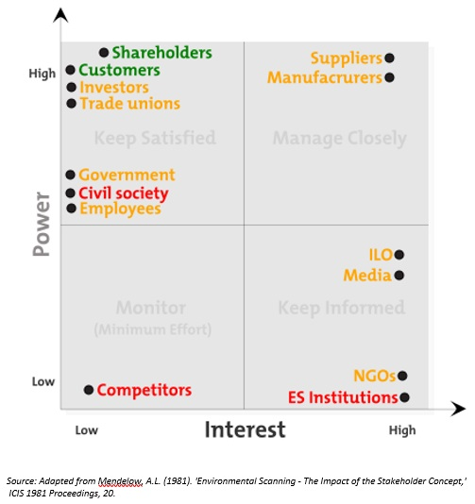
Figure 1. The Power/Interest matrix of stakeholders’ mapping
Explanation to the figure:
ES Institutions – Environmental safety institutions
Red colour represents possible threats, orange colour represents neutral impact, and the green represents a positive impact
The impact of stakeholders on ZARA’s activities classified in figure 1 is explained in figure 2.
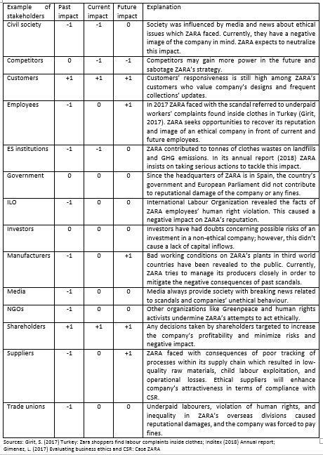
Figure 2. Explanation of ZARA’s stakeholders impact classification
Explanation to the figure:
Classification of impact is represented by numbers: negative impact is represented by ‘-1’; neutral impact is represented by ‘0’, and positive is represented by ‘+1’.
According to Inditex, the ZARA’s parent company, prioritization of the company’s stakeholders is intertwined with its business model and aligns with the 17th Sustainable Development Goal of “Partnership for the Goals” (Inditex, 2016).

Carroll’s pyramid of CSR
Economic responsibility of the company comprises its financial performance indicators. From 2010 to 2018 ZARA has been reporting EBITDA more than 3 billion euro each year with CAGR at 7% from 2013 to 2018 (Inditex, 2019). Legal responsibilities of the company are measured in terms of compliance with legal requirements of policy makers. The company is required to follow European legal acts and directives such as Company Law and Corporate Governance directives and regulations (European Commission, 2019). ZARA’s ethical responsibilities comprise with Codes of Conduct developed by the company itself. Philanthropic responsibilities of ZARA can be seen through its charity in Tanzania.
The company’s compliance with its social responsibilities is illustrated in figure 3.
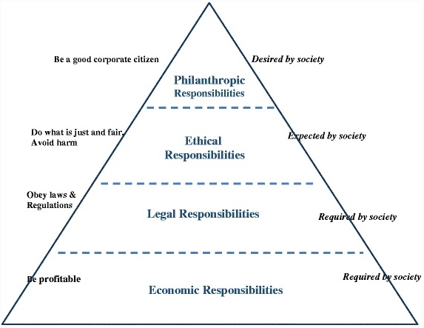
Figure 3. Carroll’s pyramid of Corporate Social Responsibility
Source: Carroll, A.B. Carroll’s pyramid of CSR: taking another look

Triple Bottom Line
In terms of economic impact, ZARA has created 171839 jobs worldwide in 2019 (Inditex, 2018). It also affects society and the environment by implementing the company’s Codes of Conduct. ZARA employees operate one of the most efficient supply chain systems in time and costs dimensions in the world developed by themselves. ZARA expects to achieve 100% sustainability of its clothes by 2025, thus, reducing the negative impact on the environment (Bain, 2018).
Organization’s footprint in economic, social and environmental aspects is demonstrated in figure 4.
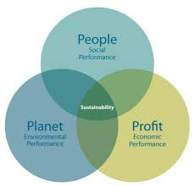
Figure 4. Triple Bottom Line framework
Source: Elkington, J. (1997) Enter the Triple Bottom Line.

Conclusions and recommendations
It was figured out that ZARA generated demand on its product by influencing its clients and reshape their preferences in clothes. Consequently, company’s ‘fast fashion’ perishable garments abound landfills worldwide and decompose resulting in global warming acceleration.
In order to provide the solution, systemic changes are required to be applied in processes of garments production, consumption, and utilization. Corporations should be involved in solving this problem.
According to World Economic Forum (2016), in the sector of fast-moving consumer goods, which accounts for $2.6 trillion annually, shifting from linear consumption to circular economy is estimated to generate $706 billion of economic benefit. Henceforth new collaboration mechanisms should be developed and introduced to the company and its stakeholders.
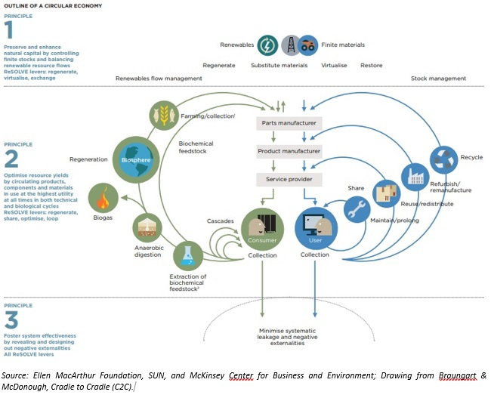
Figure 5. Circular economy model
As depicted in figure 5, stock management within circular economy model includes 4 key elements: recycling, refurbishing, repairing and re-using.
According to European Parliament (2018), the implementation of circular economy principles would reduce waste to a possible minimum, therefore, reduce the pressure from the environment, enhance the security of raw materials supply, the number of innovations, and create new jobs.
Remanufacturing of textile can reduce $GHG$ emissions by 7000 kg ${CO}_{2}-equiv$/tonne of garment waste. Polyester, as the key material for ‘fast fashion’ clothes, increased its market share to 14% in 2017(European Parliament, 2019). ZARA can implement the so-called Patagonia process of textile remanufacturing and recycling by separating polyester fabrics form other waste and processing them into small granules that might become the material for new clothes (Zamani, 2011).
Given that more than 30% of clothes in wardrobes of Europeans remains unused for more than one year (European Parliament, 2019), they can share their items with their neighbours or people with lower income in need. Implementation the principles of sharing economy, which is projected to reach $335 billion by 2025 (Lyons, 2018), (Statista, 2017), can significantly decrease overconsumption, therefore, depletion of resources and wastes issues resulting in global warming. ZARA should launch a mobile application that enables customers to rent high-quality, expensive clothes without purchasing it. Such as clothes for wedding and special occasion, protective clothes and clothes for maternity and infants.
This app should be designed to enable customers to share their garments which they don’t need any more directly with those who really need them avoiding clothes to use the store’s space for weeks or even months. Moreover, this app should enable customers to exchange their old garments for new items as a result giving ZARA an opportunity to recycle or remanufacture it, which aligns with circular economy principles.
ZARA company is advised to implement the suggested mobile application due to its alignment with the creation an effective after-use patterns of textile products which is intertwined with an idea of reduced leakage of GHG into the atmosphere and minimizing of their impact on global warming.

REFERENCES
Bain, M. (2018) Fashion’s ambitious new project to reduce its climate impact is getting help from the UN. Available at: https://qz.com/1491309/adidas-zara-hm-and-more-commit-to-reducing-fashions-climate-impact-at-cop24/ (Accessed: 14 January 2020).
Break Free from Plastic (2018) The Brand Audit Report. Available at: https://www.breakfreefromplastic.org/globalbrandauditreport2018/ (Accessed: 14 January 2020).
Carroll, A.B. Carroll’s pyramid of CSR: taking another look. Int J Corporate Soc Responsibility 1, 3 (2016) doi:10.1186/s40991-016-0004-6
Cole, C. (2010) Overconsumption is costing us the earth and human happiness. Available at: https://www.theguardian.com/environment/2010/jun/21/overconsumption-environment-relationships-annie-leonard (Accessed: 14 January 2020).
Cooper, K.-L. (2018) Fast fashion: Inside the fight to end the silence on waste. Available at: https://www.bbc.com/news/world-44968561 (Accessed: 14 January 2020).
Danziger, P.N. (2018) Why ZARA Succeeds: It Focuses on Pulling People In, Not Pushing Product Out. Available at: https://www.forbes.com/sites/pamdanziger/2018/04/23/ZARAs-difference-pull-people-in-not-push-product-out/#76c54f2023cb (Accessed: 14 January 2020).
Devlin, S. (2015) How companies make us forget we need to consume less to stop climate change. Available at: https://www.theguardian.com/sustainable-business/2015/mar/17/tricks-companies-convince-consume-address-climate-change (Accessed: 14 January 2020).
Elkington, J. (1997) Enter the Triple Bottom Line. Available at: https://www.johnelkington.com/archive/TBL-elkington-chapter.pdf (Accessed: 14 January 2020).
Ellen MacArthur Foundation, SUN and McKinsey Center for Business and Environment. (2015) Growth Within: A Circular Economy Vision for a Competitive Europe. Available at: https://www.ellenmacarthurfoundation.org/assets/downloads/government/EMF_TFPM_KeyExhibits_11-9-15.pdf (Accessed: 11 January 2020).
European Commission (2019) Company Law and Corporate Governance. Available at: https://ec.europa.eu/info/business-economy-euro/doing-business-eu/company-law-and-corporate-governance_en (Accessed: 14 January 2020).
European Committee for Standardization (2015) Textiles and textile products - Self-declared environmental claims - Use of the terms. Available at: https://standards.cen.eu/dyn/www/f?p=204:110:0::::FSP_PROJECT:39706&cs=1F183C3FFED2146E04D321EC04C835A20 (Accessed: 14 January 2020).
European Parliament (2018) Circular economy: More recycling of household waste, less landfilling. https://www.europarl.europa.eu/news/en/press-room/20180411IPR01518/circular-economy-more-recycling-of-household-waste-less-landfilling (Accessed: 13 January 2020).
European Parliament (2019) Environmental impact of the textile and clothing industry. Available at: http://www.europarl.europa.eu/RegData/etudes/BRIE/2019/633143/EPRS_BRI(2019)633143_EN.pdf (Accessed: 14 January 2020).
Friedman, M. (1970) The Social Responsibility of Business is to Increase its Profits. Available at: http://umich.edu/~thecore/doc/Friedman.pdf (Accessed: 14 January 2020).
Geyer, R., Jambeck, J.R., Law, K.L. (2017) Production, use, and fate of all plastics ever made. Science Advances 3. doi:10.1126/sciadv.1700782
Gimenez, L. (2017) Evaluating business ethics and CSR: Case ZARA. Available at: https://www.researchgate.net/publication/335193056_Evaluating_business_ethics_and_CSR_Case_ZARA (Accessed: 14 January 2020).
Girit, S. (2017) Turkey: Zara shoppers find labour complaints inside clothes. Available at: https://www.bbc.com/news/world-europe-41981509 (Accessed: 14 January 2020).
Hodari, D. (2019) For Business, Climate Change Has Become Real. Available at: https://www.wsj.com/articles/for-business-climate-change-has-become-real-11576630804 (Accessed: 14 January 2020).
Inditex (2016) Stakeholder relations. Available at: http://static.inditex.com/annual_report_2016/en/sustainable-strategy/stakeholder-relations/ (Accessed: 14 January 2020).
Inditex (2018) Annual report. 2018 in data. Available at: https://static.inditex.com/annual_report_2018/en/2018-data.html (Accessed: 14 January 2020).
Inditex (2018) Annual Report. Available at: https://static.inditex.com/annual_report_2018/pdfs/en/Inditex%20Annual%20Report%202018.pdf (Accessed: 14 January 2020).
Inditex (2019) Financial data. Available at: https://www.inditex.com/en/investors/investor-relations/financial-data (Accessed: 14 January 2020).
IPC. (2019). Online shopping frequency according to online shoppers worldwide as of October 2018. Statista. Statista Inc. Available at: https://www.statista.com/statistics/664770/online-shopping-frequency-worldwide/ (Accessed: 12 January 2020).
Johnson, G. & Scholes, K. 1999. Exploring Corporate Strategy, Europe, Prentice Hall.
Lyons, E. (2018) The changing nature of ownership: How brands are catering for ‘generation rent’. Available at: https://www.marketingweek.com/changing-nature-ownership-brands-generation-rent/ (Accessed: 14 January 2020).
Mendelow, A.L. (1981). 'Environmental Scanning - The Impact of the Stakeholder Concept,' ICIS 1981 Proceedings, 20.
Muhammed, Ö. (2013) Fashion Industry Supply Chain Issues: Zara. European Researcher, Vol. 47, pp. 999-1008.
Sanclemente-Téllez, J.C. (2017) Marketing and Corporate Social Responsibility (CSR). Moving between broadening the concept of marketing and social factors as a marketing strategy. Spanish Journal of Marketing - ESIC, Vol. 21, Supplement 1, pp.4-25
Schleeter, R. (2018) These 10 companies are flooding the planet with throwaway plastic. Available at: https://www.greenpeace.org/international/story/18876/these-10-companies-are-flooding-the-planet-with-throwaway-plastic/ (Accessed: 14 January 2020).
Statista (2017). Value of the sharing economy worldwide in 2014 and 2025 (in billion U.S. dollars). Available at: https://www.statista.com/statistics/830986/value-of-the-global-sharing-economy/ Accessed: January 14, 2020.
The Story of Stuff Project (2009) The Story of Stuff. 22 April. Available at: https://www.youtube.com/watch?v=9GorqroigqM (Accessed: 14 January 2020).
UNCC (2018) UN Helps Fashion Industry Shift to Low Carbon. Available at: https://unfccc.int/news/un-helps-fashion-industry-shift-to-low-carbon (Accessed: 14 January 2020).
United Nations Global Compact (2014) Address environmental risks and leverage opportunities. Available at: https://www.unglobalcompact.org/ (Accessed: 14 January 2020).
WBCSD (2009) Sustainable Consumption Facts and Trends. Available at: https://saiplatform.org/uploads/Modules/Library/WBCSD_Sustainable_Consumption_web.pdf (Accessed: 14 January 2020).
Wilson, M. (2018) ‘Recyclable’ is a word, not a promise — most plastic goes to landfills. Available at: https://www.sfchronicle.com/opinion/openforum/article/Recyclable-is-a-word-not-a-promise-13162266.php (Accessed: 14 January 2020).
World Economic Forum (2016) The New Plastics Economy Rethinking the future of plastics. Available at: http://www3.weforum.org/docs/WEF_The_New_Plastics_Economy.pdf (Accessed: 14 January 2020).
Zamani, B. (2011) Carbon footprint and energy use of textile recycling techniques. Available at: http://publications.lib.chalmers.se/records/fulltext/146872.pdf (Accessed: 14 January 2020).

Source: https://www.unglobalcompact.org/what-is-gc/participants/131131-Zara-Charity

