Individual assignment report

LUSH expanding business to Denmark

Focus country: Denmark
Word count: 2443
Contents
Executive summary 3
Company profile 4
Industry analysis 6
Target country Denmark 8
Labour force 8
Economic aspect 9
Legal aspect 9
Recommendations 10
Appendices 11
Appendix A: SWOT analysis 11
Appendix B: Growth rates of the global cosmetics industry by region 12
Appendix C: 12
Appendix D: PESTEL analysis 13
REFERENCES 14

Executive summary
Global personal care and beauty products industry is being examined in this report. The LUSH company was chosen as a focus of analysis.
The current state of the cosmetics industry is being described in the report. It was figured out that the cosmetics industry has been demonstrating sales growth for the sixth consecutive year. Cosmetics industry was classified as highly competitive. The increasing trend of organic eco-friendly cosmetics was identified.
Denmark was chosen as a target country for LUSH’s business expansion. Mode of entry and market conditions in Denmark are being described. PESTEL analysis is applied in the process of market perspectives assessment. An increasing trend of premium cosmetics purchases as indicated. The report examined that the most powerful group of customers in Denmark were millennials, who had enough power to reshape the market conditions.
Recommendations referred to LUSH’s entrance to Denmark are suggested. LUSH was recommended to apply foreign direct investment as an entry mode.

Company profile
LUSH is a UK-based privately-owned company selling hand-made cosmetics produced from vegetables, fruits and natural essential oils. The company's products are targeted mostly for women aged 18 – 45 living in urban areas. 17.5% of LUSH customers are males aged 25-34. The company sells its products from directly-owned stores. LUSH had 940 stores in 50 countries worldwide in 2016. The same year LUSH reported £574 million of turnover (Mohdin, 2016). Turnover of just LUSH brand alone accounted for £978 million in 2018 (Companies House, 2019). LUSH reported £19.95 million of EBITDA in 2018. LUSH global turnover growth is illustrated in figure 1.
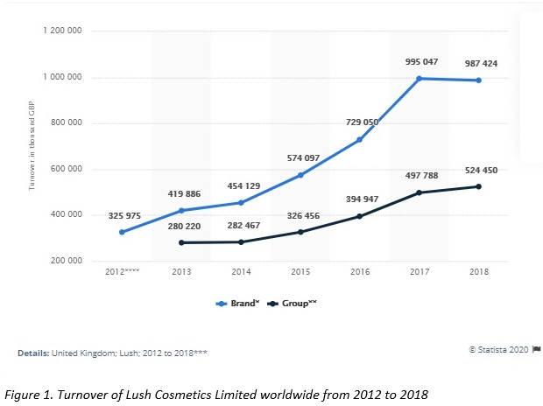The company produces ethical natural and environmental-friendly personal care products. The company does not use excess packaging by selling reliable non-liquid products. LUSH insists on its opposition towards testing cosmetics on animals (LUSH, 2019a). The company launched its new beauty brand that later was turned into a retail concept by offering very rare and exclusive cosmetics available in just four LUSH's stores. In this case, LUSH boosted its customers' loyalty.
On the annual SXSW festival and exhibition, LUSH introduced its own mobile app that allowed customers to play a game based on augmented reality and seek bath bombs hidden in the store. Hence, LUSH relies on customers-generated content instead of advertising. The company targeted its activities mainly on product innovations and customisation, utilising creative and uncommon methods of promotion (Nickalls, 2019). LUSH efficiently utilises its social media followers to increase awareness around the company and its products by covering approximately 600,000 users by each post (Jones and Mankletow, 2017).
Less than 30% of LUSH products contain animal-originated ingredients such as beeswax, etc. LUSH uses its zero-packaging policy in 30 cities around the UK. The company seeks every opportunity to share its power of decision making with its customers. LUSH customers are more likely to be highly-responsive towards fashion and are not price sensitive willing to pay more for good-quality facial care products. LUSH has set a strong relationship with customers. LUSH uses a principle of reciprocity, therefore, offering free samples of fragrances and beauty products to be tested in-store by customers. Customers feel an obligation to buy something in the store; as a result, LUSH has increased the rate of purchases per one store visit (Lush, 2019b).
In 2016 the company paid a 47.3% effective tax on the whole business of the Group since the company avoids tax havens willing to pay fair taxes regardless of the country it operates in, which aligns with the tax policy of LUSH (Mohdin, 2016).
LUSH offers a unique mix of valuable eco-friendly hand-made cosmetic products with pleasant fragrances and zero packages, and all of that allows the company to charge the premium price. Hence, LUSH uses a differentiation strategy. The SWOT analysis of the LUSH company is given in Appendix A.

Industry analysis
Global body care products market is projected to grow by 7% CAGR by 2023, with incremental growth of $318.65 million annually (Berkshire Hathaway Company, 2019). From 2005 to 2015, the global cosmetics industry has increased its value by £2.41 billion (Arie, 2017). Over the last 20 years, global beauty products market was continually growing with the average annual rate varying from 3% to 5.5%.
In terms of regional performance (Appendix B), BRICS countries accounted for 21% of the global cosmetics market, and their aggregate share was projected to reach 25% in the next few years. Online sales in this region were expected to grow by 33% from 2013 to 2018 (Lopaciuk and Loboda, 2013). Cosmetics market growth rates are depicted in figure 2.
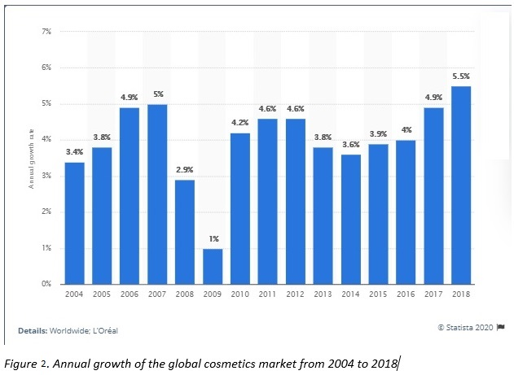
Asian cosmetics market comprises more than 3 billion customers and accounts for 20% of the US export of beauty products. Australia, Japan and South Korea imported overall at more than $1 billion of US cosmetics export. The Chinese market alone has received US cosmetics products in the equivalent of $500 to $600 million in 2015, and this amount was projected to increase to become the biggest in the world (International Trade Administration, 2016).
Usually, the cosmetics market is divided by segments such as skincare products, hair care, make-up products, fragrances and toiletries, which are the complements for each other. The market is divided into two large segments of mass products and premium products, that account for 72% and 28% respectively. CAGR of the mass segment is estimated to reach 2.4% in the next few years compared with the 3.4% rate for the premium segment. The US and China, according to Euromonitor (2017), are expected to contribute to 54% of this growth (Appendix C). Meanwhile, the US companies spend the most per one premium item. This forces US companies to differentiate their products as much as possible.
According to MarketWatch (2019), the cosmetics products market is projected to reach a market capacity of $7.13 billion by 2023. The market value of US skincare products market is expected to reach a value of $150 billion by 2023. At the same time, the global market of luxury cosmetics is expected to grow by 5.6% CAGR by 2025 crossing a value of $75.5 billion by the end of 2025 (PR Newswire, 2019).
Unconventional cosmetics products, which in 2017 dominated Korean market of beauty products, have demonstrated slow pace growth at 0.9% in 2018 compared with the previous year (Euromonitor, 2018). This can be influenced by acquisitions of Korean cosmetics brands by cosmetics giants such as Estee Lauder and MAC.
Cosmetics industry accounts for €70 billion in the EU. Europe seized one-third of the global personal care products industry, whereas the USA reached €47 billion, China and Japan achieved €29 and €18 billion, respectively. Body care and skincare products were the most competitive sectors within the European cosmetics industry and covered 25% of the industry each (Fleaca, 2016). According to Matic and Puh (2016), the global market of natural cosmetics achieved $14 billion of value in 2015.
Cosmetics industry tends to be saturated with companies competing within it. Competitive rivalry in the industry is high due to many organisations that operate in the industry manufacturing and selling cosmetics. Also, a high level of capital investment is required for the new entrant. Initially, this investment is spent on R&D and marketing. Products that derive from outside the industry are not considered as a threat of substitute for cosmetics, whereas complement enhances the demand for cosmetics products. Since there are a lot of buyers in the industry, they make a considerable impact on the company's pricing policy and marketing campaigns; thereby, the power of buyers is high. A considerable number of companies merged with or acquired other industry players. Thus, the cosmetics industry is moving towards monopolisation. Under those circumstances, suppliers don't have any impact or power over cosmetics companies. Accordingly, cosmetics are very competitive and hard industry to operate in (Kumar et al., 2006).
The largest cosmetics company in the world currently, LVMH reported $28 billion in revenues in the 2017 financial year. Perfumes and cosmetics accounted for 22.4% of the company's global sales. Average cosmetics sales of the biggest luxury goods manufacturers reached $3.68 billion. Luxury cosmetics sales have risen by 16.1% in the 2017 financial year and the industry has demonstrated the fastest growth compared with the previous financial year (Deloitte, 2019).
Every company in the global cosmetics industry wants to be ethical after Avon, and Max Factor started positioning their business as ethical and socially responsible by advertising against animal testing in 1989 and arranging diseases awareness and prevention campaigns (Kumar et al., 2006).

Target country Denmark
The market of personal care products In Denmark accounted for €366 million in 2016 (Fleaca, 2016). In 2018 retail value of Danish cosmetics industry accounted for 9,068 DKK million which is more than in 2017 by 104.7 DKK million (Euromonitor, 2020). Danish cosmetics retail market’s growth is forecasted at a 2.2% CAGR during 2017-2022 (Ken Research, 2018).
Denmark has seen a 6% increase skincare segment, which aligns with the willingness of Denmark customers to maintain healthy skin as part of a healthy lifestyle pursuit (Euromonitor, 2018). The segment of skin care products in Denmark has been demonstrating continuous growth for 9 years. In 2018 skin care products increased their market share by 2% to 39% (Kosmetik-og hygiejnebranchen, 2019). The country also witnessed an increased impact of the global premium skincare usage trend on Danish customers. Premium skincare and colour cosmetics became the most frequent items purchased by Danish in 2018, consequently, their share has risen by 7% and 9% respectively. Under those circumstances, it can be assumed that LUSH would have considerable market share in Denmark if it expanded this country's market. Since Danish customers were ready to pay a higher price for high-quality organic cosmetics that might enhance their appearance and eliminate issues of irritated or inflamed sensitive skin, existing consumers' tastes and preferences don't need any action from LUSH to reshape them, therefore, the company can adapt its existing promotion practices.
Cosmetics products in Denmark are being sold through store-based retailing, which accounts for 82.7% of retail value. 42% of personal care products were purchased from non-grocery specialists, 40.7% of these products were purchased from specialised health and beauty retailers, and 35% of these retailers were drugstores and pharmacies (Euromonitor, 2019). Quarterly turnover of personal care products in Denmark accounted for 265 million and 297 DKK million in the 1st and 2nd quarter of 2019 respectively. Overall, total turnover of cosmetics products in the first half of 2019 exceeded this indicator of 2018 by 61 DKK (Statistics Denmark, 2019b).
E-commerce, that shaped the vast majority of industries, influenced the market of personal care products in Denmark by selling more cosmetics online than the average share goods sold online globally by 7% (Nguyen, 2018).
There are 6 major players on Danish cosmetics market, such as Unilever, Matas, Baiersdorf, L'Oréal Danmark, McNeil and Body Shop.

Labour force
The total population of Denmark was 5.797 million in 2018 according to World Bank (2020). Labour force of Denmark was estimated at 3,009,405 people in 2019. Danish employees on average are better educated their neighbours from Belgium and the UK, since they spend 19.1 years schooling averagely. Denmark was ranked 11th in the global HDI ranking (UNDP, 2020). In 2018 728 employees were officially working in the skin care industry. Compared with 2017, the number of skin care and beauty treatment industry workers increased by 12.5% (Statistics Denmark, 2019). The unemployment rate in Denmark was reported at 4.8% of the total labour force and it has been decreasing for 9 years in a row starting from 2011. During that period unemployment decreased twice as much as it was in 2011. Dynamics of the number of cosmetics industry employees is illustrated in figure 3.
Detailed PESTEL analysis of Danish cosmetics industry is given in Appendix D.

Economic aspect
Danish GDP annual growth was reported at 2.4% in 2019, the Danish economy has demonstrated continuous GDP growth at a rate of more than 2% for the fourth consecutive year starting from 2015. The share of people actively using the internet accounted for 97.6% of the population. VAT rate is currently 16.5% (World Bank, 2020).
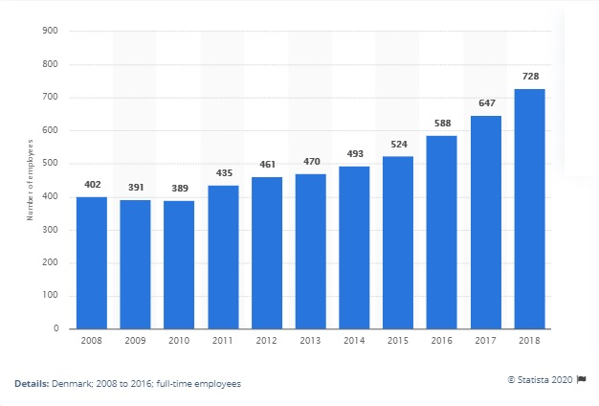
Figure 3. Number of employees working in cosmetics industry for the period from 2008 to 2018

Legal aspect
Following EU regulation No. 1223/2009 advertising and distribution of cosmetics or its ingredients that were tested on animals are banned (Grum, 2019). Accordingly, this regulation influences the Danish market of personal care products.

Recommendations
Given that Danish customers show low price sensitivity and that demand for unique high-quality cosmetics products demonstrates low elasticity, LUSH can adopt differentiation strategy on the wide industrial scale and charge a premium price. Such price might be slightly higher than average prices in the industry, but it corresponds with the value created for LUSH consumers by its products. Also, LUSH can apply focused differentiation by targeting a narrower segment of customers, such as a segment of millennials, who tend to buy rather a skincare and body care products than bath and shower toiletries. This aligns with increased younger generation awareness of healthy lifestyle importance, preferable physically active vacations and strongly embedded principles and behavioural choices about disease prevention and desire to prolong natural health as much as possible. Thus, LUSH does not need to carry additional expenses on products promotion, since Danish customers have very similar tastes and preferences, and consumer behaviour as British customers do. Moreover, it can be assumed that Danish customers account for the biggest share of LUSH 'perfect customers' than British consumers due to the smaller number of customers that 'profess' healthy lifestyle. In terms of expanding the company's business to Denmark, LUSH was given several recommendations.
- LUSH may use joint venture as the mode of entry since potential venture partner will share investment risk with the company. In this case, LUSH will access local resources, such as labour force, raw materials and manufacturing facilities (e.g. distribution store in the high footfall area). However, there is a risk of depreciation of existing competitive advantage, therefore, the company might lose its uniqueness and customers loyalty which is important assets for LUSH.
- Since some LUSH products require additional customer service provided by LUSH experienced and knowledgeable employees, directly owned stores become justified despite possible high maintenance costs. As a result, exporting is non-efficient and cannot provide considerable cost advantages and customer relationship.
- In order to have full control over its activities and keep customers satisfied by serving them in directly-owned stores, LUSH is advised to apply foreign direct investment strategy of expansion. This strategy can allow LUSH to obtain Danish enterprise with deployed resources and capabilities and start operating in the shortest time.

Appendices

Appendix A: SWOT analysis
Strength:  - Strong relationship with customers and good customers’ experience;  - Strong emphasis on the company’s ethical compliance and strong focus on CSR within its operations;  - Strong beliefs and values embedded in company’s culture;  - High level of customer and brand loyalty;  - Wide product range;  - Positive reputation of the company;  - Innovative promotion methods that give the company customers’ stickiness. | Weaknesses:  - Higher operational costs than those in competitors due to hand-made production;  - Directly-owned stores are more expensive in maintenance;  - Highly-perishable products due to the absence of preservatives;  - High dependence of the company on shop service;  - The additional workforce needed to provide special customer service in stores, therefore, additional operational expenses.
Opportunities:  - An increased customers’ need to buy more sustainable and organic products;  - By utilising this all-natural trend, the company can shape customers’ behaviour with a focus on a healthy lifestyle;  - The industry growth rate is constantly increasing by 4% annually on average;  - Lower dependence on oil prices and prices for chemicals than other companies in the industry;  - An increasing share of e-commerce and online purchase trend;  - Skincare products are the fastest growing sector in the cosmetics industry, with a 9% growth in 2015. | Threats:  - High level of competitive rivalry in the industry;  - Price-consciousness of customers (i.e. demand elasticity);  - It’s necessary to comply with all of the various requirements;  - Special approach to products usage is needed compared with other companies’ products;  - One of the highest tax rates in the European Union (VAT rate is 16.5%);  - Macroeconomic cycles and exchange rate fluctuations.

Appendix B: Growth rates of the global cosmetics industry by region
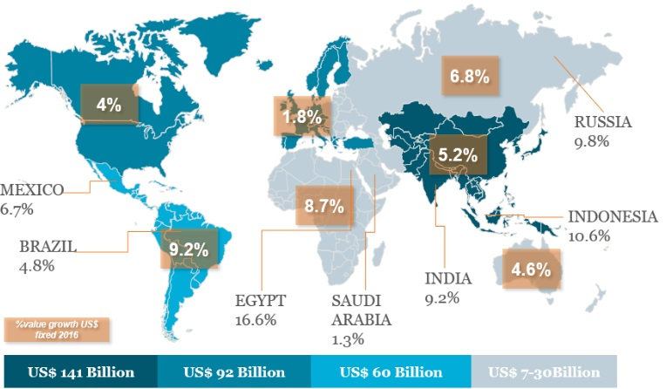
Source: Euromonitor (2017) Reimagining Growth in the Global Beauty Industry

Appendix C:
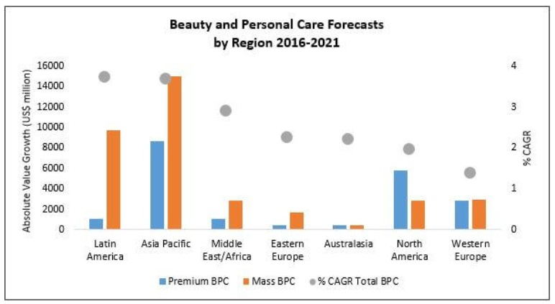
Source: Euromonitor (2017) Reimagining Growth in the Global Beauty Industry

Appendix D: PESTEL analysis
Political | One of the least corrupted countries in the world. High level of democracy and rule of law, as well as transparent courts and justice. The free trade agreement is proliferated on the movement of goods between Denmark and the rest of the EU.
Economic | Denmark has a high level of welfare and that is represented in high GDP per capita and constant annual GDP growth. Denmark has the lowest level of unemployment among other OECD members. Annual income per capita is projected to increase by around 20% as well as individuals’ disposable income. Denmark belongs to those countries that have high indirect taxes rates (e.g. VAT in Denmark is set at 25%).
Social | Denmark is usually ranked high in the global Human Development Indicator ranking, which means that Danish has a high level of education and professional skills, therefore more well-paid jobs. Denmark is the country with a high level of urbanisation. Almost every Danish is aware of climate change and air pollution, that is why Danish tend to buy more organic and environment-friendly products. The issue related to social aspects is ageing of the Danish population and low birth rates. These existing trends can change customers’ behaviour and force companies to adjust their strategy to given circumstances.
Technical | Due to high literacy rates and a high level of technological development within the country, more than three-quarters of Danish are active Internet and electronic devices users. Also, Denmark accounts for a significant share of global e-commerce purchases.
Environmental | The Danish government is actively implementing green energy initiatives and aiming to completely switch from fossil fuels towards renewable energy sources.  Regulations are being changed continuously in order to minimise or totally reduce greenhouse gas emissions.  Danish rainy weather influences transportation and often causes delays.
Legal | Denmark became the EU member in 1973 and established first environmental law in the world.  Implementation and compliance with international standard ISO 22716:2007 allowed to adjust processes of cosmetics production, storage and transportation to globally recognised practices.  National Organic Association of Denmark was given the right to audit food and beauty products manufacturers for compliance with established requirements of organic product.  Intellectual property, such as cosmetic recipes and companies’ trademarks, are protected by the Patent and Trademark Office of Denmark.

REFERENCES
Arie, S. (2017), "Cosmetic industry regulation is only skin deep", BMJ (Clinical research ed.), vol. 357, pp. 1.
Berkshire Hathaway Company (2019) Global Body Masks Market 2019-2023. Available at: https://www.businesswire.com/news/home/20200117005105/en/ (Accessed: 20 January 2020).
Companies House. (2019). Turnover of Lush Cosmetics Limited worldwide from 2012 to 2018 (in 1,000 GBP). Statista. Statista Inc. Available at: https://www.statista.com/statistics/892361/turnover-lush-cosmetics-limited-worldwide/ (Accessed: 21 January 2020.).
Deloitte (2019) Global Powers of Luxury Goods 2019. Available at: https://www2.deloitte.com/content/dam/Deloitte/ar/Documents/Consumer_and_Industrial_Products/Global-Powers-of-Luxury-Goods-abril-2019.pdf (Accessed: 20 January 2020).
Euromonitor (2017) Reimagining Growth in the Global Beauty Industry. Available at: https://blog.euromonitor.com/reimagining-growth-in-the-global-beauty-industry/ (Accessed: 20 January 2020).
Euromonitor (2018) Five Key Insights from Euromonitor International’s Beauty and Personal Care 2018. Available at: https://blog.euromonitor.com/five-key-highlights-euromonitor-internationals-beauty-personal-care-2018/ (Accessed: 21 January 2020).
Euromonitor (2019) Beauty and Personal Care in Denmark. Available at: https://www.portal.euromonitor.com/portal/Analysis/Tab (Accessed: 22 January 2020).
Euromonitor (2020) Beauty and Personal Care Sources 2019: Denmark. Available at: https://www.portal.euromonitor.com/portal/researchsource/tab (Accessed: 22 January 2020).
Fleaca, B. 2016, "The Analysis of the Cosmetic Industry Based on Processes", FAIMA Business & Management Journal, vol. 4, no. 2, pp. 48-56.
Grum, T. (2019) Global ban on animal testing: where are we in 2019? Available at: https://www.cosmeticsdesign-europe.com/Article/2019/03/05/Global-ban-on-animal-testing-where-are-we-in-2019 (Accessed: 20 January 2020).
International Trade Administration (2016) Asia Personal Care & Cosmetics Market Guide. Available at: https://www.trade.gov/industry/materials/AsiaCosmeticsMarketGuide.pdf (Accessed: 20 January 2020).
Jones, M., Manktelow, N. (2017) How Lush Has Grown Without Spending A Dime on Advertising. Available at: https://cmo.adobe.com/articles/2017/11/the-cmo-show-natasha-ritz-brand-communications-manager-lush-cosmetics.html#gs.tyl6r9 (Accessed: 20 January 2020).
Ken Research (2018) Health & beauty Retailing in Denmark, Market Shares, Summary and Forecasts to 2022. Available at: https://www.kenresearch.com/consumer-products-and-retail/cosmetics-and-personal-care/health-beauty-denmark-market/157390-95.html#details (Accessed: 22 January 2020).
Kosmetik- og hygiejnebranchen. (2019). Market share of cosmetic and personal care products in Denmark from 2010 to 2018, by type. Statista. Statista Inc. Accessed: January 24, 2020. https://www.statista.com/statistics/824176/market-share-of-cosmetic-and-personal-care-products-in-denmark-by-type/ (Accessed: 22 January 2020).
Kumar, S., Massie, C. & Dumonceaux, M.D. 2006, "Comparative innovative business strategies of major players in cosmetic industry", Industrial Management & Data Systems, vol. 106, no. 3, pp. 285-306.
L’Oréal. (2019). Annual growth of the global cosmetics market from 2004 to 2018*. Statista. Statista Inc. Available at: https://www.statista.com/statistics/297070/growth-rate-of-the-global-cosmetics-market/ (Accessed: 22 January 2020).
Lopaciuk, A., Loboda, M. (2013) Global beauty industry trends in the 21st century. Available at: http://www.toknowpress.net/ISBN/978-961-6914-02-4/papers/ML13-365.pdf (Accessed: 20 January 2020).
LUSH (2019a) Is LUSH an Ethical Company? Available at: https://uk.lush.com/article/lush-ethical-company (Accessed: 20 January 2020).
LUSH (2019b) More than marketing. Available at: https://uk.lush.com/article/more-marketing (Accessed: 20 January 2020).
MarketWatch (2019) Global Cosmetics Products Market 2019 Available at: https://www.marketwatch.com/press-release/global-cosmetics-products-market-2019-analysis-by-size-share-types-increasing-demand-by-changing-lifestyle-and-business-growth-opportunities-till-2023-2019-04-10 (Accessed: 20 January 2020).
Matic, M. & Puh, B. 2016, "Consumers' purchase intentions towards natural cosmetics", Ekonomski Vjesnik, vol. 29, no. 1, pp. 53-64.
Mohdin, A. (2016) Lush sells bath bombs and cosmetics. It also gives nearly £6 million a year to far-left groups. Available at: https://qz.com/609641/lush-sells-bath-bombs-and-cosmetics/ (Accessed: 20 January 2020).
Nguyen, M. (2018) Small Beauty Formats to Profit from Rising E-Commerce. Available at: https://blog.euromonitor.com/small-beauty-formats-profit-rising-e-commerce/ (Accessed: 20 January 2020).
Nickalls, S. (2019) Lush Is Using Machine Learning and AI to Make Wasteful Packaging and Signage Irrelevant. Available at: https://www.adweek.com/brand-marketing/lush-is-using-machine-learning-and-ai-to-make-wasteful-packaging-and-signage-irrelevant/ (Accessed: 20 January 2020).
PR Newswire (2019) Global Luxury Cosmetics Market (2019-2025). Available at: https://www.prnewswire.com/news-releases/the-global-luxury-cosmetics-market-size-is-expected-to-reach-75-5-billion-by-2025--rising-at-a-market-growth-of-5-6-cagr-during-the-forecast-period-2019-2025-300952698.html (Accessed: 20 January 2020).
Statistics Denmark. (2019). Number of employees working in the beauty treatment and skin care industry in Denmark from 2008 to 2018. Statista. Statista Inc. Available at: https://www.statista.com/statistics/865066/number-of-employees-in-the-beauty-treatment-industry-in-denmark/ (Accessed: 22 January 2020).
Statistics Denmark. (2019b). Sales turnover of the beauty treatment and skin care industry in Denmark from 2nd quarter of 2017 to 2nd quarter of 2019 (in million DKK). Statista. Statista Inc. Available at: https://www.statista.com/statistics/865043/quarterly-sales-turnover-of-beauty-treatment-industry-in-denmark/ (Accessed: 22 January 2020).
UNDP (2019) Human Development Index Ranking. Available at: http://hdr.undp.org/en/content/2019-human-development-index-ranking (Accessed: 22 January 2020).
World Bank (2020) World Development Indicators. Available at: https://databank.worldbank.org/reports.aspx?source=2&country=DNK (Accessed: 22 January 2020).
XE (2020) Currency converter. Available at: https://www.xe.com/currencyconverter/convert/?Amount=1&From=DKK&To=USD (Accessed: 22 January 2020).

Danish krone – official currency in Denmark. Current exchange rate 1 DKK = $0.15 USD. Source: XE Currency converter (2020)
Human Development Indicator ranking is presented annually by United Nations Development Programme.

